Migration Yyc-net yyc.com
- Change LinkedIn + LinkedIn openGraph
- Change Resume
Set up Thunderbird, Betterbird, TypeApp for new email roy@ai-yyc.com
- Activate new domain by Wed April 22 latest (see email from WHC April 8)
- Fix master_nav.js issue with WHC. Once fixed, confirm all nav inks and assignment sublinks working in prod
- Logo global search/replace: master_nav.js (logo file name)
- syle.css adjust as needed for new logo size (.site-logo size property)
- Global Search/replace “.net” with “.com”: 10 results in 5 files (not two master_nav.js instances temporarily):
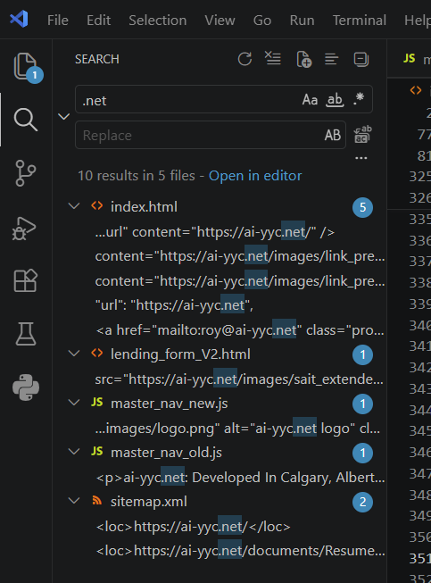
- Index.html: update og meta tags (x3)
- Index.html: update application/ld+json (x1)
- Index.html: update email address (X1)
- Lending_form_v2: Needs to be replaced with a hybrid. Talk to William & Team (X1)
- Master_nav.js – change (X2)(as stated above in logo section)
- Sitemap.xml: Rename to sitemap_old (X2)

WHC
Confirm migration steps, then execute. Ideally real-time phone call. How to point files to the new domain? See ticket #4195941
Set up roy@ai-yyc.com email address
OpenGraph config
XML sitemap setup
Cloudfare DNS: Add domain to cloudflare, wait for WHC to change nameservers, wait for DNS propagation

